1. **For this practical we required MongoDB, postman, vs code install on your computer**
2. **Create empty folder for example ass_3_b and open this folder in vs code**
3. **Open cmd terminal up to this folder**
4. **For this practical we need package.json, so we run following cmd command :**

>npm init

Note : hit enter upto 9 to 10 times

>npm I mongodb

Note : it is for installing monogdb inside the project

>npm i express

1. **Create file index.js in practical folder**
2. **Create file mongodb.js in practical folder**
3. **Go to MongoDB compass and connect following link and click connect button**

Link = ( mongodb://localhost:27017 )

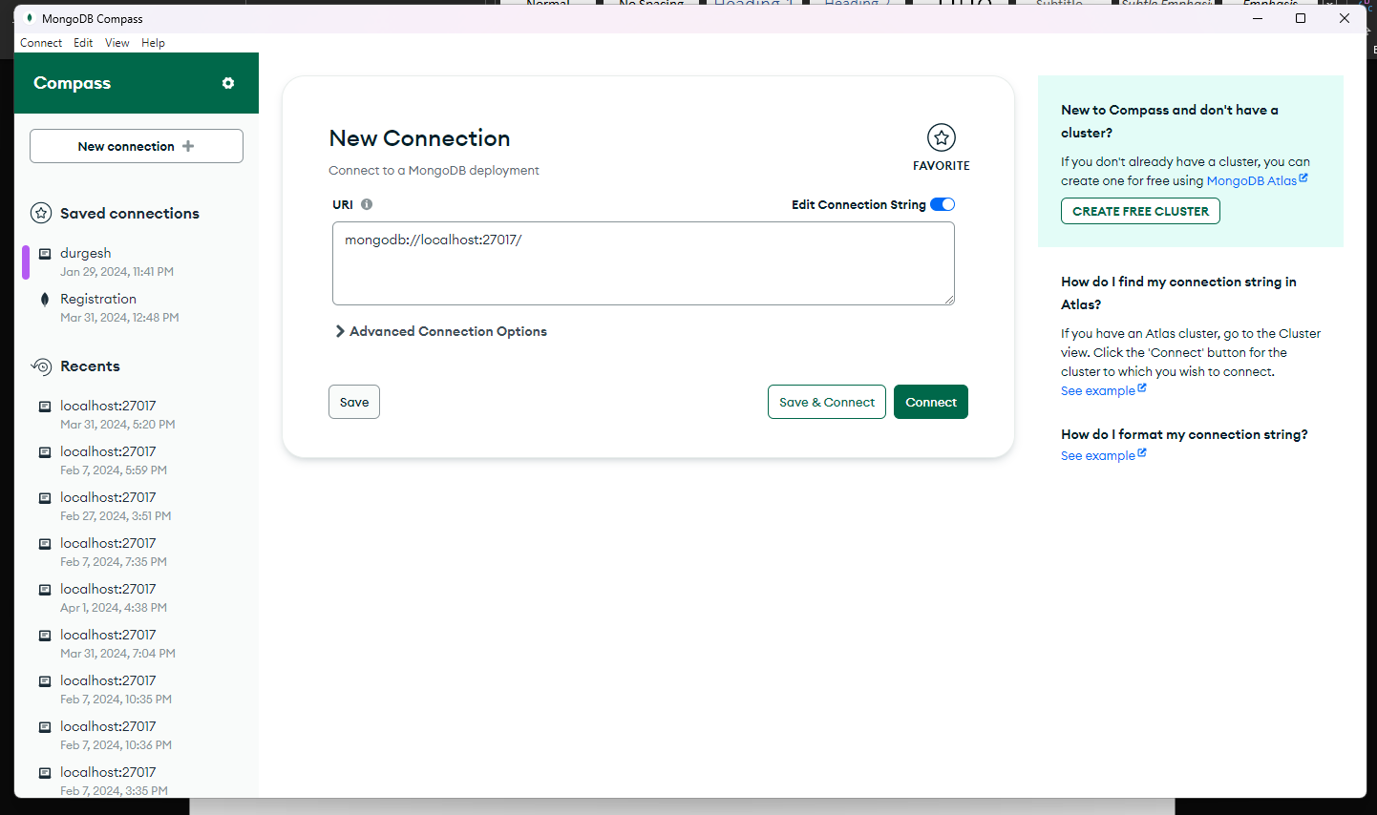



1. **After connect link we show this page and click on ( >_MONGOSH )**

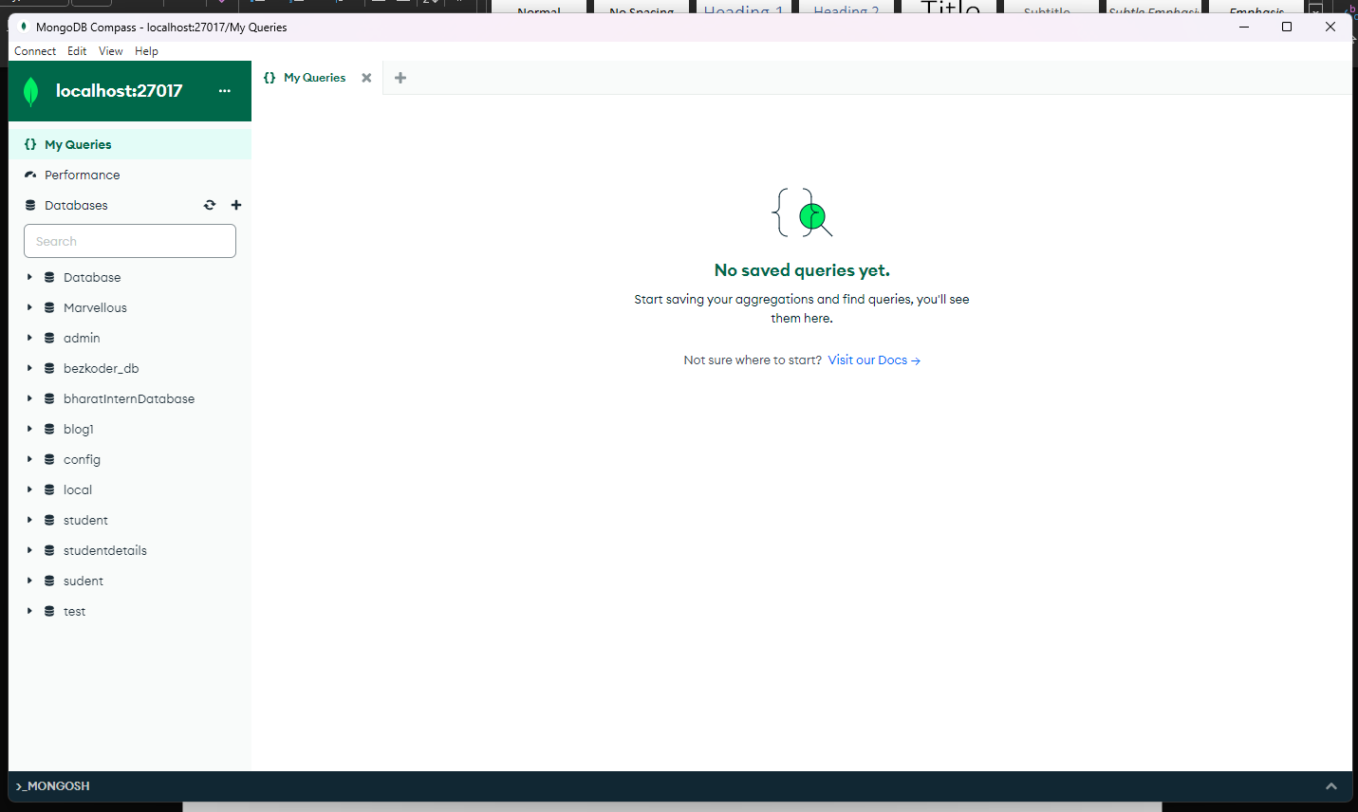



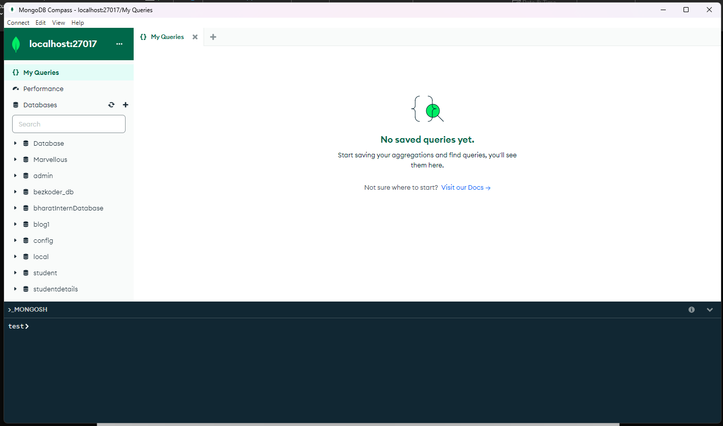

1. **After the mongosh open the write one by one command for create data base and collection :**

>show dbs

>use student

>db.createCollection('profile')

>db.profile.insertOne({name:"durgesh", email:"durgesh123@gmail.com", city:"pune"})

1. **After that check thestudent and then profile as follow :**

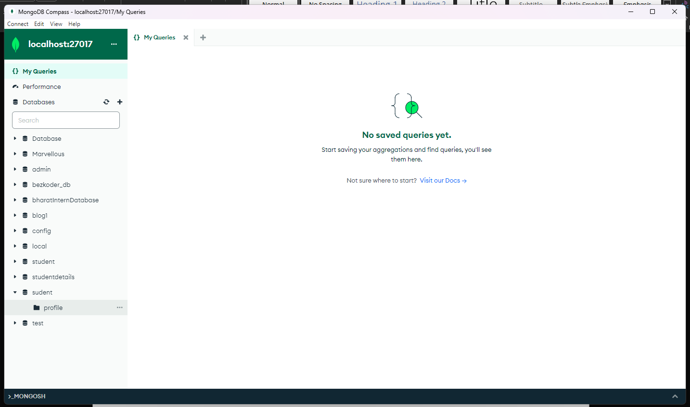



1. **After that refresh the profile the you see the data**

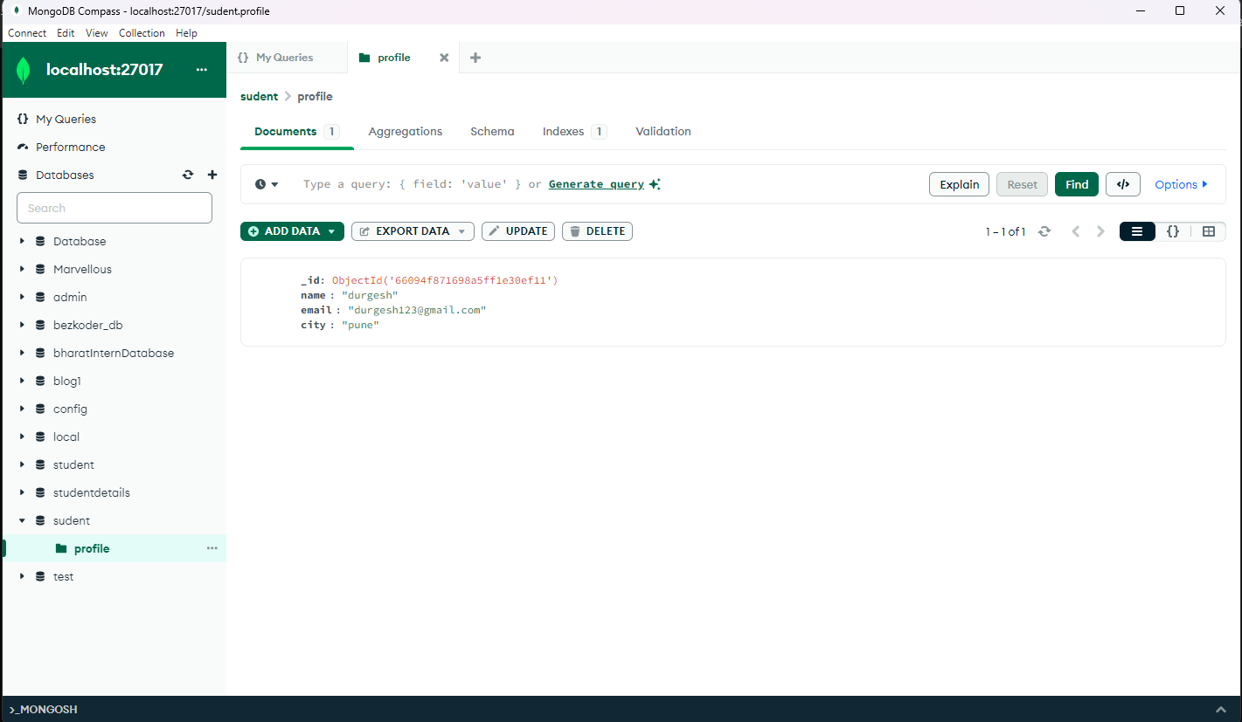



1. **Go to mongodb.js file in practical folder and write following code :**

const { MongoClient } = require('mongodb');

const url = "mongodb://localhost:27017";

const database = 'student';

const client = new MongoClient(url, { useUnifiedTopology: true });

const dbConnect = async () => {

*try* {

*await* client.connect(); *// Connect to MongoDB*

        const db = client.db(database); *// Select the database*

*return* db.collection('profile'); *// Return the collection*

    } *catch* (error) {

        console.error('Error:', error); *// Log any errors*

*throw* error; *// Re-throw the error to be handled by the caller*

    }

};

module.exports = dbConnect;

1. **Go to index.js file in practical folder and write following code :**

const dbConnect = require('./mongodb');

const express = require('express');

const app = express();

app.use(express.json())

*// GET API*

app.get('/', async (*req*, *res*) => {

*try* {

        const collection = *await* dbConnect(); *// Connect to MongoDB*

        const result = *await* collection.find().toArray(); *// Query the collection*

*res*.send(result); *// Send response*

    } *catch* (error) {

        console.error('Error:', error); *// Log any errors*

*res*.status(500).send('Internal Server Error'); *// Send a generic error response*

    }

});

*//post API*

app.post('/',async(*req*,*res*)=>{

    let result = *await* dbConnect();

    result = *await* result.insertOne(*req*.body);

*res*.send("Data Inserted Successfully")

});

*//put API*

app.put('/:name',async(*req*,*res*)=>{

    let result = *await* dbConnect();

    result = *await* result.updateOne({name:*req*.params.name},{$set:*req*.body});

*res*.send("Data updated Successfully")

});

*// delete API*

app.delete('/:name',async(*req*,*res*)=>{

    let result = *await* dbConnect();

    result = *await* result.deleteOne({name:*req*.params.name});

*res*.send("Data deleted Successfully")

});

const PORT = 3000;

app.listen(PORT, () => {

    console.log(`Server is running on http://localhost:${PORT}`);

});

1. **To run code, open cmd for practical folder then following cmd command enter** :

>node index.js

1. **Then open the postman**

Note = connect the internet your computer or laptop

Then open postman and click on new button and then click on HTTP

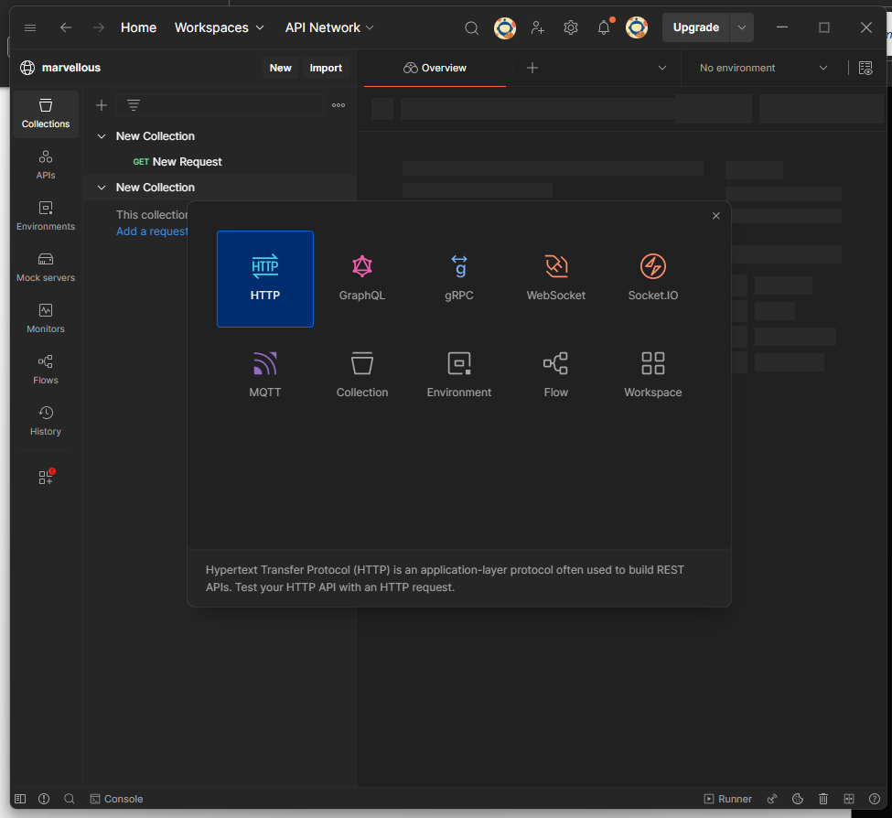



1. **Enter the URL in it as follow as :**

URL = http://localhost:3000

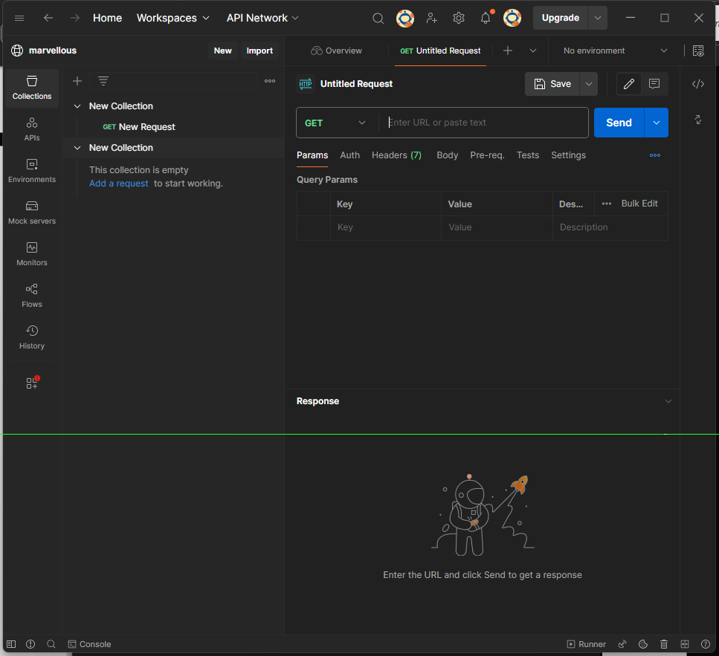



1. **After the enter the URL select get method and JSON formate and send the request as follow as :**



